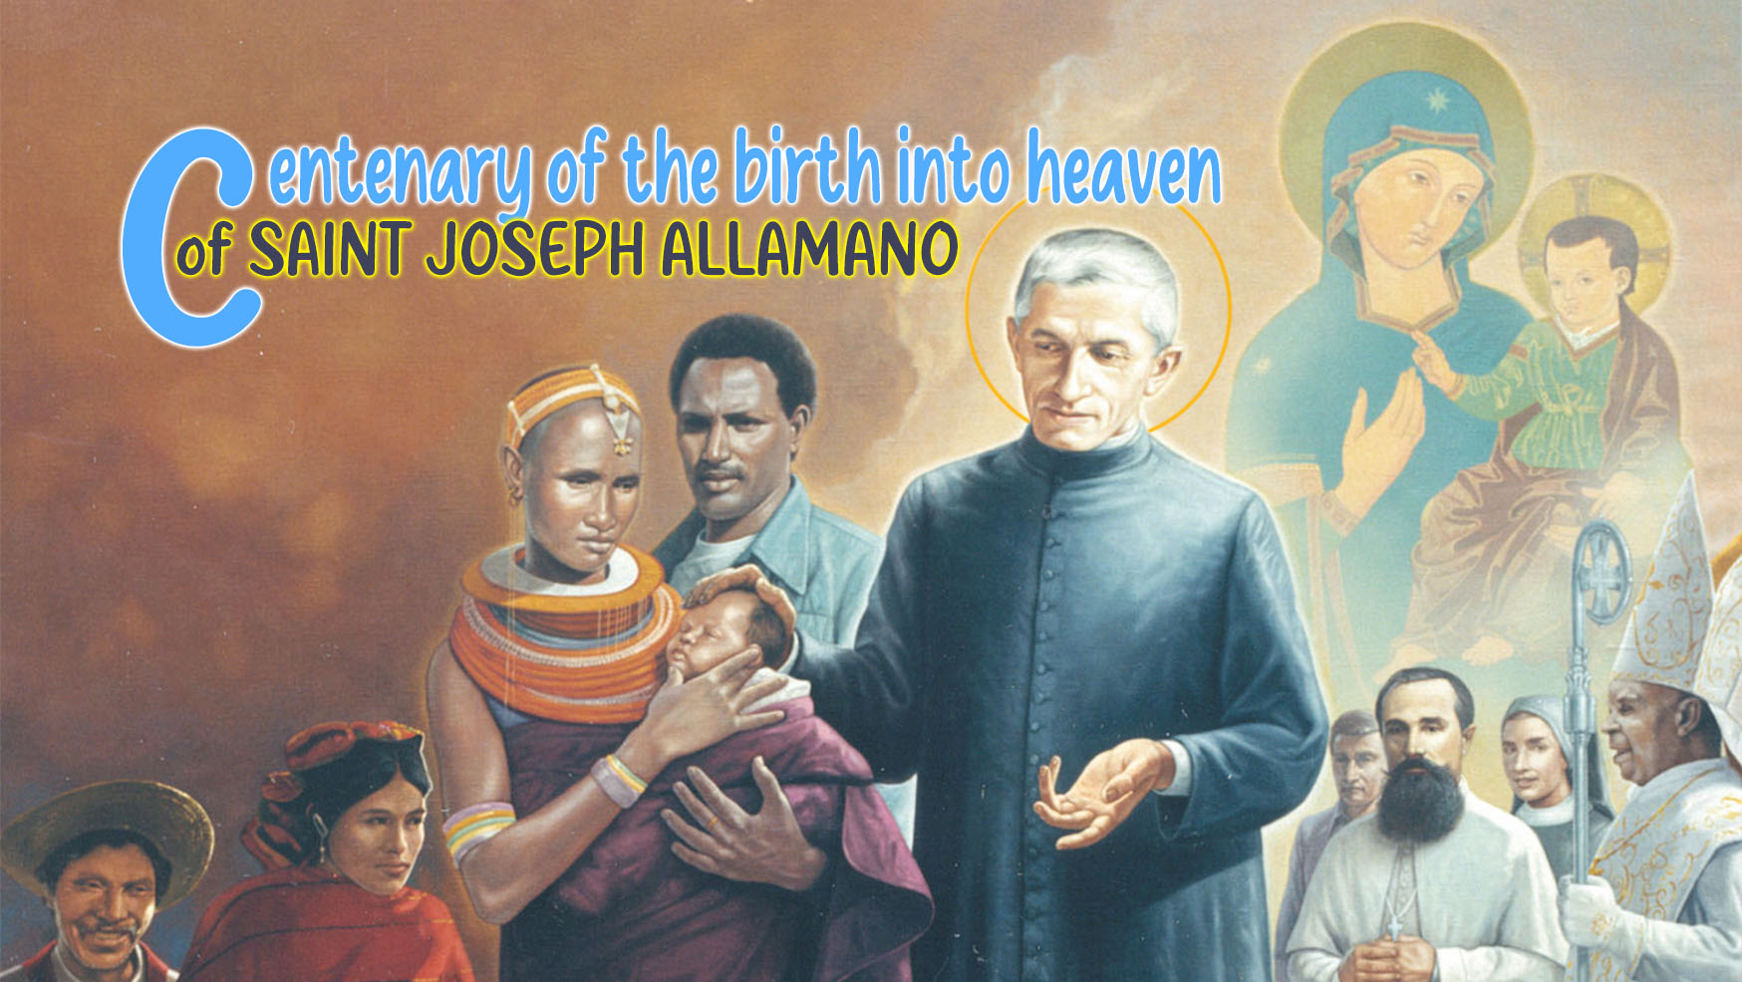

12

Holiness in
total surrender

We celebrate the First Centenary of the Birth into Heaven of St. Joseph Allamano!
His death was a true birth into heaven, the epilogue of an earthly life lived solely and totally for the Lord he had always loved, and for the Consolata, the most tender Mother, by whom he felt beloved, his "Benjamin", "Secretary and Treasurer". From these great loves of his sprang love for the person, for the "souls" to be saved, near and far, with a missionary impulse that exceeded all limits. Let us contemplate some significant details of his return to God.

Pushing the boundaries
With his silent but attentive style, which does good without noise but done well, with an energy and industrious constancy, Joseph Allamano really goes far. It is surprising in him that he has reached 75 years of age with poor health since he was a child. This same physical fragility prevented him from realizing his missionary dream, a desire cultivated as a young seminarian strengthened by the meeting with Cardinal Guglielmo Massaia. At the age of 49, when it seemed that his life was coming to an end but was miraculously restored, he founded two Missionary Institutes. On his birthday, January 21, 1917, in a conference to the Sisters he said: "How many years... 66 completed and 17 of rebirth! The latter are no longer really mine. What did I say to the Lord when this work began? Remember, Lord, everything, but not even a hint of pride, and if trials are necessary, send, torments as well." Moreover, without reaching Africa, he guided the first steps of the mission, developing together with his missionaries a very particular method of evangelization by intertwining the first proclamation with human promotion. And all this he did in addition and not in place of all the tasks carried out in the Shrine of the Consolata. Truly a life that challenged the limits of nature because it was given totally and unreservedly, in profound communion with the Lord, welcomed and blessed by Him and made fruitful to the end like the branches united to the Vine that bear much fruit (cf. John 15:5).
St. Joseph Allamano approaches the end of his life radiating great peace and serenity and with an unshakable trust in God for having lived seeking and fulfilling His Will, as he expresses in the letter of 1923 addressed to the missionaries, on the occasion of his golden jubilee:
"With a heart full of deep consolation, I celebrated the fiftieth anniversary of my sacred priestly ordination. This was a singular grace for me, which humanly could not have been expected for me; and only the goodness of God deigned to grant me... I am consoled, however, that I always tried to do the will of God recognized in the voice of the Superiors. If the Lord blessed many works to which I put my hand, to sometimes excite admiration, my secret was to seek God alone and His Holy Will, manifested to me by my Superiors."
As the definitive encounter with the Lord approaches, with the passage from earthly life to the Father's house, the most beautiful words emerge in Joseph Allamano, full of what really matters, what gives full meaning to life:
"I thank you, O Mary, ... that I have already been your caretaker for 35 years. What have I done in these 35 years? If someone else had been in my place, what would he have done? But I don't want to investigate; If I had been so bad, you would not have kept me so many years: this is certainly a sign of predilection. … You kept me, so you must be happy. - And it seems to me that Our Lady smiled."
"Before long I shall have to appear before the judgment seat of God and give an account; but I will be able to say that I have done my duty".
"For you I lived many years, and for you I consumed property, health and life. I hope by dying to become your protector in Heaven."

Peace as a gift
Sr. Emerenziana Tealdi, MC, who assisted him in the last days, on February 15, seeing him worsen expresses herself as follows:
"In my simplicity with an anguished heart I understood that things were coming to an end and then I said to him: "Oh! Father, here we are, you are dying!" He replied in a faint voice: 'And you pray that God's will be done.'"
The earthly life of St. Joseph Allamano ended at dawn on February 16, 1926, as described by Sr. Paola Rossi, MC, who kept a diary of his last days:
"From time to time the beloved Father's wonderful eyes stare upwards, to one place, and he smiles... we wait for Our Lady, we are sure that She is close to her beloved Son, we feel her presence strongly, and... we nourish the childish hope of seeing her take his soul to heaven. And here is the Mother! At four minutes past five, some louder sobs let his beautiful and holy soul, ... fly to Paradise, in the arms of Our Lady".
Sr. Emerenziana also states that after her death "I felt in my soul a very great inexplicable peace that I attribute to her immediate intercession in Heaven". A similar experience is described by Fr. Bartolomeo Moriondo, IMC:
“…We felt in us like as a sense of joy, of the certainty that Canon Allamano no longer needed our prayers. Thus, we felt the need to recommend ourselves to Him, we personally, as well as His Institute and ours. We did this with tears in our eyes, because separation from loved ones is always painful, but with a joy, a certainty in our hearts that even we could not explain to ourselves."

"I Will Bless You"
St. Joseph Allamano whispers until his last breath that which is one of the foundations of his holiness: the Will of God. His life was a continuous surrender to God and a constant commitment to carry out God’s plan with unwavering fidelity. He, a blessing father, promises to continue to guide and bless his sons and daughters: "When I am up there, I will bless you even more: I will always be at the balcony'". Today, as we celebrate his life and holiness, we ask that a shower of blessings poured upon all those who invoke him with confidence and upon a humanity thirsting for peace and consolation.


"At the feet of our Most Holy Consolata
I bless you with all my heart"

Conferenze alle Missionarie, vol. 3, pp. 17, 436.
Conferenze alle Missionarie, vol. 2, p. 11.
Lettere, IX/2, 653.
Conferenze alle Missionarie, Vol. 1, p. 136.
Conferenze ai Missionari, Vol. 2, p. 722.
Lettere X, 540.
Conferenze alle Missionarie, Vol. 2, p. 482.

